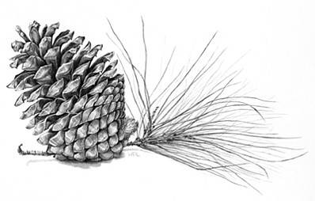
Directions: Your group will be given a chapter of Walden to read independently. Once read your task will be to create an OVERSIZED illustrated children’s book that SIMPIFIES what Thoreau writes about in that chapter. Your book must be in YOUR OWN WORDS (not Thoreau’s) except the 5 Quotes you MUST place somewhere in your book.
Your group’s book is due no later than October 12th /13th . Your group will present your final product in class.
Critical Attributes
- Must be between 8 and 12 pages that measure at least 12 inches by 18 inches.
- Each page must include a HAND-DRAWN ILLUSTRATION
- You must summarize Thoreau’s writing in the chapter assigned; no group can be larger than 4 students.
The Parts of the Book are as follows:
- Cover – Include the name of your chapter, the title of the book, author’s name, one QUOTE from your chapter, your group names and illustration. See sample below
“Sounds” from Walden
By Henry David Thoreau

[QUOTE and ILLUSTRATION]

Translated by YOUR GROUP MEMBERS
- Forward - One page that includes a 600 word typed introduction from your group which gives your group’s thoughts and insights about the chapter. The forward should be written for an adult audience and should address nuances in Walden that cannot be adequately explored in your children’s book.

Additional Questions to Consider in Forward
- What are some on the main messages that Thoreau is exploring in your chapter?
- How is your chapter in Walden relevant to a modern audience? What concepts most apply?
- What are the impacts of Thoreau’s literary devices on the reading/message? (ie., Greek allusions, complex/compound sentences, figurative language)
- Given Thoreau’s concepts in the chapter you have read, how do you think Thoreau would critique modern society?
*The forward must be submitted into turnitin.com

- Body of the Book (6 to 10 pages)
  - Summary/ Commentary
  - Quotes (5)
  - Illustrations

- Back of Book – Include a biography of Henry David Thoreau. This can be done in bullet points. You must include a picture of him with his biography (this can be printed or drawn).

