*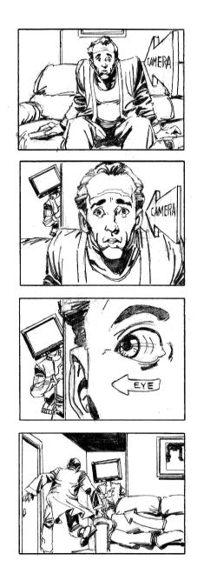Objectives*:

RC 2.1: Analyze both the features and rhetorical devices of different types of public documents.

RC 2.6: Critique the power and validity, and truthfulness of arguments set forth in public documents, their appeal to both friendly and hostile audiences and to the extent in which the arguments anticipate and address reader concerns and counterclaims (e.g., appeal to reason, authority and emotion) ELA Standards:

 **ESLR: Thinker & Communicator**—apply critical thinking skills/write effectively

Purpose: The purpose of this project is to evaluate the argument proposed by Neil Postman in his expository text, *Amusing Ourselves to Death*, and validate the issues through the use of contemporary research.

**Task I** – Close reading (annotation) of the primary source, *Amusing Ourselves to Death*, along with a delivery project/mind map for one of the chapters

**Task II** – Selection of two current event articles which address the shift in our culture to a media and entertainment driven society. Please include articles that specifically address the *most recent* technological innovations (e.g., “i-technologies” or the like). One article should support Postman’s theory, and one article should refute Postman.

1. Write a brief summary about your selected source article, and a biography about the writer; this information should be structured similarly to the background information provided in your *Patterns for College Writing* textbook.
2. Annotate articles focusing on the following:
   * Central Message
   * Rhetorical Strategies/Style
   * Use of concessions and rebuttals
   * Target Audience
   * Arrangement of ideas
   * Sentence structure and diction
   * Fallacies in Logic

At the end of each article write a brief personal response (***not summary***) to the issues raised specifically any new learning you encountered.

**Task III**

Read and annotate an excerpt from *Everything Bad is Good* for You by Steven Johnson (posted on the Weebly: <http://ahosi.weebly.com>). Please print a copy to annotate and include in your project portfolio.

1. Write a brief biography about the writer, Steven Johnson; this information should be structured similarly to the background information provided in your *Patterns for College Writing* textbook.

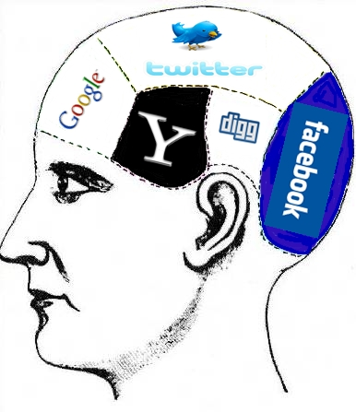

1. Annotate that article focusing on the following:
   * Central Message
   * Rhetorical Strategies/Style
   * Use of concessions and rebuttals
   * Target Audience
   * Arrangement of ideas
   * Sentence structure and diction
   * Fallacies in Logic

At the end of the excerpt, write a brief personal response (***not summary***) to the issues raised specifically any new learning you encountered.

**Task IV**

Write an essay that defends, challenges, or qualifies Postman’s ideas about the nature of contemporary discourse. You must use evidence from Postman and cite from at least one of your sources in **Part II** or **Part III**.

**OR**

Select one rhetor from the above tasks and write an essay in which you analyze their use of rhetorical strategies by explaining how these strategies build their persuasive argument on the role of technology and its impact on public discourse.

* **Criteria for Submission**: Your work must be organized in a folder beginning with Task I, ending with Task IV. Background information and essay must be submitted to turnitin.com, prior to the class turn indue date.